**Identification Of Fake Currency Found In India**

Mr. Ratnesh K. Choudhary1  
*Computer Science & Engineering,   
S. B. Jain Institute Of Technology, Management & Research, Nagpur*Maharashtra, India  
[ratneshchoudhary@sbjit.edu.in](mailto:ratneshchoudhary@sbjit.edu.in)

Ms. Shweta Gupta4  
*Computer Science & Engineering,  
S. B. Jain Institute Of Technology, Management & Research, Nagpur.*Maharashtra, India  
[shwetag.cse21@sbjit.edu.in](mailto:shwetag.cse21@sbjit.edu.in)

Mr. Swapnil Mahajan2  
*Computer Science & Engineering,   
S. B. Jain Institute Of Technology, Management & Research, Nagpur.*Maharashtra, India  
[swapnilmahajan@sbjit.edu.in](mailto:swapnilmahajan@sbjit.edu.in)

Ms. Prachi Borate5  
*Computer Science & Engineering,  
S. B. Jain Institute Of Technology, Management & Research, Nagpur.*Maharashtra, India  
[prachib.cse21d@sbjit.edu.in](mailto:prachib.cse21d@sbjit.edu.in)

Mr. Vibhanshu Mandaogade7  
*Computer Science & Engineering,   
S. B. Jain Institute Of Technology, Management & Research, Nagpur.*Maharashtra, India  
[vibhanshum.cse21@sbjit.edu.in](mailto:vibhanshum.cse21@sbjit.edu.in)

Mr. Pravin Jaiswal3  
*Computer Science & Engineering,   
S. B. Jain Institute Of Technology, Management & Research, Nagpur.*Maharashtra, India  
[pravinj.cse21@sbjit.edu.in](mailto:pravinj.cse21@sbjit.edu.in)

Ms. Tannu Shahu6  
*Computer Science & Engineering,   
S. B. Jain Institute Of Technology, Management & Research, Nagpur.*Maharashtra, India  
[tannus.cse21@sbjit.edu.in](mailto:tannus.cse21@sbjit.edu.in)

*Abstract*—The development of shaded printing technology has increased the rate at which large-scale counterfeit notes are produced. Banknotes are still in circulation due to their dependability and simplicity of use, even if computerized financial exchanges are becoming more common and the use of paper money has been declining recently. Counterfeiting is the practice of making copies of legitimate currency. As a result, the Indian government does not support fake money. Only the RBI is in charge of printing money in India. The RBI must deal with the problem of counterfeit banknotes every year once they have been vetted and issued onto the market. We have suggested employing a convolutional neural network to identify fake Indian currency in order to solve the aforementioned issue (CNN). Our method recognises fake currency by analysing the photos of the currency. The CNN is trained to learn the feature map of the corresponding Indian money using data sets for the 50,100,500,2000 rupees notes. After learning the feature map, the network is equipped to detect fake currency in real time. The suggested technique is quicker and successfully finds counterfeits of the 50,100,500,2000 currencies. Our proposed model had a Overall accuracy of 97.00% and a Training accuracy of 96.00%.

**Keywords**—Convolutional Neural Network (CNN), Currency, Deep Learning.

# **Introduction**

The detection of fake currency is a severe problem that has an impact on the economies of practically every nation, including India. To extract elements like security thread, intaglio printing (RBI logo), and identification mark, which have been implemented as security features of Indian currency, image processing methods have been used. The handling of a huge quantity of fake currency presents new challenges [5]. Therefore, using machines (either independently or in support of human experts) streamlines and improves the efficiency of note recognition. The security thread feature of a currency note can be extracted to detect counterfeit money. The most often used convolutional neural network technique for spotting counterfeit money. The difficult task of feature extraction in digital image processing. It entails the extraction of both hidden and exposed properties of Indian banknotes [13]. Using many security features instead of just one is another innovative innovation. Because banks have to deal with the issue of damaged or counterfeit money notes, automatic machines are more useful. Consequently, using a machine makes the note recognition process more simple and organized. A significant number of fake Indian currency notes were printed and sold in the market. Even though counterfeit money is printed accurately, it may probably be identified with some effort [18]. To resolve these issues the system for recognizing Indian banknotes is quite helpful. Automated Recognition of money notes is introduced with the use of feature extraction, classification based on SVM, and neural networks to address this type of issue. To recognize and verify the value of currency, extracted features from the image of the note will be used [27]. If a currency image is fake or real. However, as technology advances, there is also an increase in the methods used to produce fake versions of these currencies. These fake or counterfeit notes harm society in a number of way. CNN is used in the suggested method. A dataset of 232 photos is used to test the created model. It uses a dataset image of authentic 50, 100, 500, 2000rupee notes and counterfeit notes for Indian cash. Training Accuracy was 96.00%, while Overall Accuracy was 97.00% for the identification of counterfeit money.

# **Literature Survey**

Binod Prasad, C. S. Patil, R. R. Karhe, and P. H. Patil [2], The paper introduces an Indian coin recognition system utilizing artificial neural networks (ANNs). The system aims to recognize Indian coins of denominations `1, `2, `5, and `10 with rotation invariance and classify them based on their value. It addresses the need for a robust recognition system capable of handling noisy environments. The approach involves preprocessing, feature extraction using Discrete Wavelet Transform (DWT), and classification using ANN..

Laavanya, M., and V. Vijayaraghavan [3], Counterfeit currency notes pose a significant threat to the economy of a country, necessitating the development of reliable detection systems. In this research, Ayush Antre et al. propose a system that employs Convolutional Neural Networks (CNNs) for accurately distinguishing between real and fake currency notes. The system operates in real-time, processing images of currency notes to determine their authenticity.

Agasti, Tushar, Gajanan Burand, Pratik Wade, and P. Chitra [4], The paper addresses the challenges faced by visually impaired individuals in identifying Indian currency notes, especially after the demonetization initiative in India. It proposes an automated system based on Convolutional Neural Networks (CNNs) to assist visually impaired individuals in currency recognition.

Tele, Gouri Sanjay, Akshay Prakash Kathalkar, Sneha Mahakalkar, Bharat Sahoo, and Vaishnavi Dhamane [5],The paper proposes a neural network classification technique for detecting counterfeit Indian currency notes. The study highlights the use of image processing and neural networks to automatically identify and distinguish between genuine and fake currency notes. Key security features of Indian currency, such as the security thread, RBI Logo, and identifying marks, are extracted using image processing methods. These features are then used to generate a combined score for distinguishing between real and counterfeit currency.

Darade, Sonali R., and G. R. Gidveer [6], The paper addresses the issue of counterfeit Indian currency notes in the context of the rapid growth of the Indian economy. Despite strong security features endorsed by the Reserve Bank of India (RBI), counterfeit money remains a major problem due to advancements in color printing technology. The proposed model employs a three-layered Deep Convolutional Neural Network (Deep ConvNet) to efficiently detect counterfeit Indian currency notes, achieving an accuracy of 96.6

Kumar, S. Naresh, Gaurav Singal, Shwetha Sirikonda, and R. Nethravathi [7], The paper presents a computer vision-based approach for detecting fake Indian paper currency. The methodology involves extracting currency features and developing datasets for currency detection. The authors utilize the ORB (Oriented FAST and Rotated BRIEF) algorithm and Brute-Force matcher approach for feature extraction, enabling accurate detection of Indian banknotes. The system achieves an average accuracy of up to 95.0% when tested on various denominations of Indian currency.

Suresh, Ingulkar Ashwini, and P. P. Narwade [9],  Counterfeiting of currency poses a significant threat to both individuals and the economy. Current fake currency detectors are limited to banks and corporations, leaving common people and small businesses vulnerable. In this project, the authors propose a software-based system to detect and invalidate fake Indian currency using advanced image processing and computer vision techniques.

Kulkarni, Anushka, Prachi Kedar, Aishwarya Pupala, and Priyanka Shingane [10], The paper addresses the issue of counterfeit Indian currency notes through the utilization of Convolutional Neural Network (CNN). Despite advancements in printing technology, counterfeit money remains a significant problem, impacting the economy. The proposed method involves training a CNN to identify fake Indian currency notes by analyzing their images. The model achieves high validation and training accuracies of 97.52% and 94.25%, respectively, for  
detecting counterfeit ₹2000 and ₹500 notes.

# **Aim & Objectives**

**AIM:** The aim of an Indian currency detection project is to develop a correct and efficient system recognition and Indian currency notes.

**OBJECTIVES:**

* **Currency Recognition Accuracy**: Develop a system capable of accurately recognizing Indian currency notes of various denominations.
* **Efficiency Improvement**: Enhance the efficiency of the currency recognition process to ensure quick and reliable detection.
* **Robustness to Variations**: Design the system to be robust against variations in image quality, lighting conditions, and other environmental factors.
* **Real-time Detection**: Implement real-time detection capabilities to enable rapid identification of currency notes.

# **Existing Systems**

**1. AD 818 Magnify Money Detector:** The AD 818 Magnify Money Detector is an advanced currency authentication system designed to accurately identify counterfeit banknotes. Renowned for its precision and reliability, the AD 818 employs a combination of cutting-edge technologies to ensure the integrity of financial transactions.

**2. Fake Currency Check Machine:** The "Fake Currency Check Machine" is an essential tool in the arsenal of businesses, financial institutions, and individuals seeking to protect themselves from the pervasive threat of counterfeit currency. This sophisticated system is designed with the sole purpose of swiftly and accurately identifying fake banknotes, thereby safeguarding transactions and preserving financial integrity.

**3. Fake Metal Money Detector:** The Fake Metal Money Detector is an indispensable tool in the arsenal of businesses, financial institutions, and security personnel tasked with safeguarding against counterfeit coins and other metallic currency substitutes. This advanced system is meticulously designed to detect and differentiate between genuine and counterfeit metal coins with unparalleled accuracy and efficiency.

**4. Truscan Neo Automatic Fake Currency Detector:** The TruScan Neo Automatic Fake Currency Detector represents a pinnacle in currency authentication technology, offering unparalleled accuracy, speed, and reliability in identifying counterfeit banknotes. Tailored for the needs of businesses, financial institutions, and retail establishments, the TruScan Neo is a cutting-edge solution designed to safeguard against the ever-present threat of fraudulent currency transactions.

In the realm of identifying counterfeit currency, the comparison between Convolutional Neural Networks (CNNs) and Artificial Neural Networks (ANNs) reveals distinct advantages and considerations. CNNs, tailored for image-related tasks, harness hierarchical feature extraction to discern intricate patterns within images, a capability unmatched by ANNs. This superior feature extraction, coupled with their data efficiency, empowers CNNs to generalize well even with limited training data, making them ideal for tasks reliant on visual cues like currency authentication [4] . However, this proficiency comes at the cost of increased computational complexity and training time, contrasting with the simplicity and interpretability of ANNs. Despite these disparities, CNNs offer robustness to variations in input data, ensuring consistent performance across diverse scenarios, a crucial aspect in the nuanced domain of counterfeit currency detection. Thus, while both architectures hold relevance, CNNs emerge as the preferred choice for their adeptness in handling image data and extracting pertinent features, ultimately enhancing accuracy and reliability in currency authentication endeavors [7].

# **Proposed System**

Our significance in this system proposal focuses on the identification of fake currency that is prevalent in the Indian market. In our approach, counterfeit currency is found by removing the security thread component from the currency note. CNN was used to create our suggested system for identifying fake cash. The photos of currency note dataset is created in order to train the suggested system. Images of notes worth 50, 100, 500, 2000rupees are created using augmentation. To boost the dataset count, augmentation techniques like resizing and rotating are used. All currency photos are annotated after augmentation, and the images are then saved in a separate folder with labels. The network and images are now prepared for training. The network learns the characteristics of genuine cash notes for 50, 100, 500, 2000rupees once the training procedure is complete.

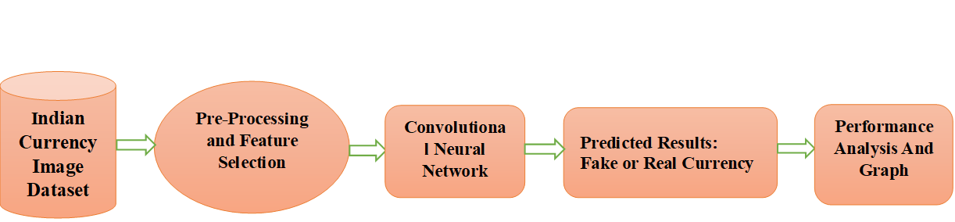

**Fig 1. Proposed system**

## **2.1 Indian Currency Image Dataset**

Many categories of Indian currency vary in value estimation, colour utilisation, printing quality, printing medium, and other factors that allow for easy visual differentiation. In any case, due to the similar measures of the various currencies, content and colour will not at all help the visually impaired individual, and measurement can cause confusion.

## **2.2 Pre-processing and Feature Selection**

The quality and format of image data are crucial for effective feature extraction in machine learning tasks. In the case of currency recognition, the spatial resolution (the number of pixels per unit area of an image) ensures that important textual and graphical details on the money are discernible. Brightness resolution, on the other hand, concerns the ability of the digital image to accurately represent the light intensity of the real-world object. Both resolutions are essential for capturing the nuanced features that distinguish different denominations and validate authenticity.

**Preprocessing Steps:**

1. **Rescaling and Normalization:** Pixel values are often rescaled from a range of 0-255 to a smaller range (e.g., 0-1) to speed up computations and improve convergence in neural networks.

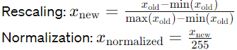

1. **Noise Reduction:** Images might be processed to reduce noise - typically using filters like Gaussian blur or median filters - to make the subsequent feature extraction more robust.



1. **Data Augmentation:** Techniques such as rotation, scaling, and flipping are employed to artificially expand the training dataset. This helps the model generalize better to new, unseen examples by simulating different perspectives and deformations that might occur in practical scenarios.

## **2.3 Training the Dataset :**

To train a robust neural network for currency recognition, the approach generally starts with a basic architecture which is gradually refined to improve performance. This iterative refinement is guided by the performance metrics such as accuracy and the loss function.

**Loss Function:** The choice of loss function is crucial since it directly affects the efficiency and effectiveness of the training process. In binary classification tasks such as counterfeit detection, binary cross-entropy is a commonly used loss function. It measures the "distance" between the predicted class probabilities and the actual labels, aiming to minimize these discrepancies over training iterations.



Where:

* 𝐽*J* is the binary cross-entropy loss.
* 𝑁*N* is the number of samples.
* 𝑦𝑖*yi*​ is the true label of the 𝑖𝑡ℎ*ith* sample.
* 𝑝𝑖*pi*​ is the predicted probability of the 𝑖𝑡ℎ*ith* sample.



Where:

* 𝐽*J* is the cross-entropy loss.
* 𝑚*m* is the number of examples.
* 𝐶*C* is the number of classes.
* 𝑦𝑖(𝑐)*yi*(*c*)​ is the true label (1 if example 𝑖*i* belongs to class 𝑐*c*, 0 otherwise).
* 𝑎𝑖(𝑐)*ai*(*c*)​ is the predicted probability that example 𝑖*i* belongs to class.

**Activation Functions:** ReLU (Rectified Linear Unit) is widely used due to its simplicity and efficiency in non-linearly transforming input features while mitigating the vanishing gradient problem common with traditional sigmoid functions.

*f*(*x*)=max(0,*x*)

Where:

* 𝑥*x* is the input to the function.
* 𝑓(𝑥)*f*(*x*) is the output of the function.



Where:

* 𝐴[𝐿]*A*[*L*] is the output probability vector.
* 𝑍[𝐿]*Z*[*L*] is the input to the softmax function.

***2.3 Convolutional Neural Networks******(CNN)***

CNNs are specifically designed for processing data that has a grid-like topology, such as images. An image is represented as a stack of 2D arrays (channels), with each pixel value indicating the intensity in a particular channel (e.g., RGB).

**Core Components:**

1. **Convolutional Layers:** These layers apply a set of learnable filters to the input. Each filter detects specific features such as edges, colors, or textures at various locations in the input. The output of this layer is a feature map that highlights these detected features.



Where:

* 𝑍𝑖,𝑗[𝑙]*Zi*,*j*[*l*]​ is the output activation at position (𝑖,𝑗)(*i*,*j*) in the 𝑙𝑡ℎ*lth* layer.
* 𝐹ℎ[𝑙]*Fh*[*l*]​ and 𝐹𝑤[𝑙]*Fw*[*l*]​ are the height and width of the filter in the 𝑙𝑡ℎ*lth* layer.
* 𝑛𝑐[𝑙−1]*nc*[*l*−1]​ is the number of channels in the input volume.
* 𝑊𝑘,𝑙,𝑚[𝑙]*Wk*,*l*,*m*[*l*]​ is the weight corresponding to the 𝑘𝑡ℎ*kth* filter, 𝑙𝑡ℎ*lth* layer, and 𝑚𝑡ℎ*mth* channel.
* 𝐴𝑖′,𝑗′,𝑚[𝑙−1]*Ai*′,*j*′,*m*[*l*−1]​ is the activation at position (𝑖′,𝑗′)(*i*′,*j*′) in the 𝑚𝑡ℎ*mth* channel of the input volume.
* 𝑏[𝑙]*b*[*l*] is the bias term.

1. **Pooling Layers:** Following convolutional layers, pooling (subsampling or down-sampling) reduces the spatial size (width and height) of the feature maps, thereby decreasing the number of parameters and computation in the network. It also helps in making the detection of features invariant to scale and orientation changes.



Where:

* 𝐴𝑖,𝑗,𝑘[𝑙]*Ai*,*j*,*k*[*l*]​ is the output of the pooling layer at position (𝑖,𝑗,𝑘)(*i*,*j*,*k*).
* 𝐴2𝑖+𝑚,2𝑗+𝑛,𝑘[𝑙−1]*A*2*i*+*m*,2*j*+*n*,*k*[*l*−1]​ is the input activation at position (2𝑖+𝑚,2𝑗+𝑛,𝑘)(2*i*+*m*,2*j*+*n*,*k*) in the (𝑙−1)𝑡ℎ(*l*−1)*th* layer.

1. **Fully Connected Layers:** After several convolutional and pooling layers, the high-level reasoning in the neural network is done via fully connected layers. Neurons in a fully connected layer have full connections to all activations in the previous layer, as seen in regular neural networks. Their outputs are computed based on these activations, which represent high-level features in the data.



Where:

* 𝑍[𝑙]*Z*[*l*] is the output of the fully connected layer.
* 𝑊[𝑙]*W*[*l*] is the weight matrix.
* 𝐴[𝑙−1]*A*[*l*−1] is the input activation.
* 𝑏[𝑙]*b*[*l*] is the bias term.

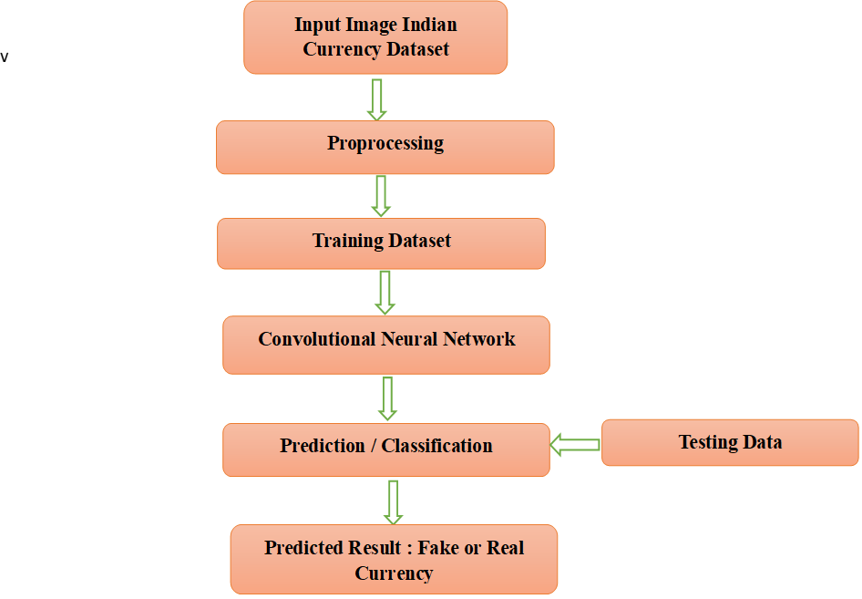

**Fig 2. Prediction flow chart**

By stacking multiple convolutional and pooling layers, CNNs are able to learn hierarchical feature representations of the input data, making them highly effective for complex image recognition tasks such as currency validation.

ConvNets are made to handle data that is presented as numerous arrays, such as a colour image made up of three 2D arrays that each include the pixel intensities for the three different colour channels. There are many different types of data modalities that take the shape of numerous arrays, including 1D signals and sequences for language, 2D visuals or audio spectrograms, and 3D video or volumetric images. Local connections, shared weights, pooling, and the utilisation of many layers are the four fundamental concepts that underpin ConvNets, which exploit the characteristics of natural signals. A typical ConvNet's architecture is divided into various stages. Convolutional layers and pooling layers make up the initial few phases of the process. Convolutional layers organise its units into feature maps, and within each feature map, each unit is related to specific local patches in the feature maps of the preceding layer using a collection of weights called a filter bank.

Convolution, non-linearity, and pooling are stacked in two or three levels, followed by additional convolutional and fully-connected layers. ConvNet's Backpropagating gradients function is as straightforward as that of a standard deep network, making it possible to train all of the filter banks' weights.

# **Methodology**

* **Data Collection:** Collect a diverse dataset of images containing both genuine and counterfeit Indian currency notes. Ensure the dataset represents various denominations, conditions, and perspectives to make the model robust to real-world scenarios.
* **Data Preprocessing**: Standardize the images by resizing them to a consistent resolution, such as 300x300 pixels, to ensure uniformity across the dataset. Convert the images to grayscale to reduce computational complexity and normalize pixel values to a range between 0 and 1 to facilitate model training.
* **Model Selection**: Choose a suitable machine learning model for image classification tasks, such as a Convolutional Neural Network (CNN). CNNs are well-suited for image analysis tasks due to their ability to automatically learn features from raw pixel data.
* **Model Training**: Train the selected model using the preprocessed dataset. Adjust model architecture and hyperparameters, such as the number of layers, kernel sizes, and learning rates, to optimize performance. Utilize techniques like data augmentation to increase the diversity of training samples and prevent overfitting.
* **Model Evaluation:** Assess the trained model's performance using a separate validation dataset. Measure metrics like accuracy, precision, recall, and F1 score to gauge the model's effectiveness in distinguishing between genuine and counterfeit currency notes.
* **Fine-tuning and Optimization:** Fine-tune the model based on performance feedback from the validation dataset. Experiment with optimization techniques such as learning rate scheduling, batch normalization, and dropout regularization to improve the model's generalization ability and robustness.
* **Testing:** Test the optimized model on a separate test dataset to evaluate its effectiveness in real-world scenarios. Measure performance metrics and compare them with the validation results to ensure consistency and reliability.
* **Deployment:** Once satisfied with the model's performance, deploy it for practical use. Integrate the model into a user-friendly application or system, providing an interface for users to input currency images and receive predictions on their authenticity.
* **Continuous Improvement:** Monitor the model's performance in real-world applications and gather feedback from users. Continuously update the model based on new data, emerging counterfeit techniques, and advancements in machine learning algorithms to enhance its accuracy and reliability over time.

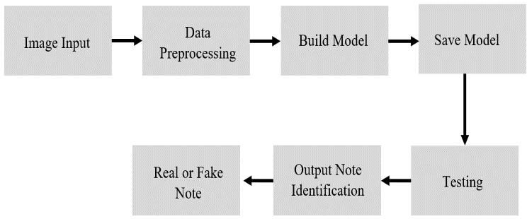

**Fig 3. Block Diagram**

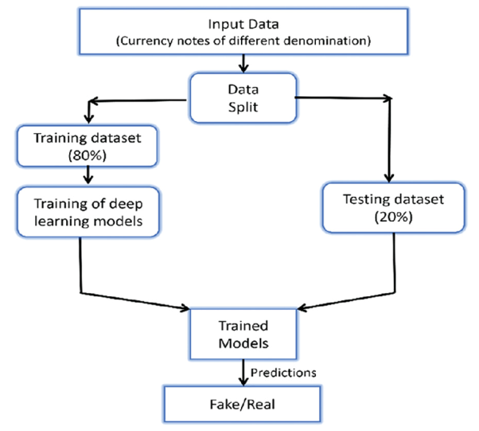

**Fig 4. System Internal Flowchart**

# **Module Description**

1. **Data Collection Module:**
   1. Responsible for sourcing and gathering a diverse dataset of Indian currency notes, including both genuine and counterfeit examples.
   2. Collects images from various sources, ensuring representation of different denominations, conditions, and counterfeit techniques.
   3. Organizes and labels the dataset to distinguish between genuine and counterfeit currency notes.
2. **Data Preprocessing and Model Training Module:**
   1. Preprocesses the collected dataset to prepare it for model training.
   2. Performs tasks such as resizing images to a uniform size, converting them to grayscale, and normalizing pixel values.
   3. Divides the preprocessed dataset into training and testing subsets for model evaluation.
   4. Trains the machine learning model, such as a Convolutional Neural Network (CNN), using the training dataset.
   5. Optimizes model parameters and architecture to achieve the best performance on the training data.
3. **Testing and Evaluation Module:**
4. Evaluates the trained model's performance using the testing dataset to assess its effectiveness in counterfeit detection.
5. Applies the trained model to classify images of currency notes as genuine or counterfeit.
6. Calculate accuracy to measure the model's performance.
7. Analyzes the results to identify areas for improvement and potential adjustments to the model or dataset.
8. Provides insights into the model's reliability and suitability for practical deployment in real-world scenarios.

# **Technology Used**

* **Convolutional Neural Networks (CNN):** CNNs are tailored for image analysis, learning intricate patterns from images. They're ideal for distinguishing genuine and fake banknotes by automatically extracting relevant features.
* **Programming Language:** Python: python's simplicity and rich ecosystem make it perfect for machine learning. Libraries like TensorFlow, NumPy, and Pandas are essential for implementing and training CNN models.
* **Machine Learning Framework:** TensorFlow, NumPy, and Pandas: TensorFlow provides tools for building and training CNNs. NumPy and Pandas are used for data handling and preprocessing, essential for feeding data into the model.
* **Image Processing Libraries:** OpenCV: OpenCV offers functionalities for image preprocessing and analysis. It's crucial for tasks like resizing, grayscale conversion, and contour extraction in counterfeit currency detection.
* **Development Tools:** Google Colab: Google Colab provides a cloud-based environment for machine learning development. It offers free GPU and TPU resources, making it convenient for experimenting with CNN architectures and training strategies.

# **Results and Analysis**

In evaluating the effectiveness of CNNs and ANNs for counterfeit currency identification, a critical aspect lies in comparing their accuracies across training, validation, and testing datasets. CNNs consistently demonstrate superiority in accuracy across these metrics, exhibiting the highest performance levels. During training, CNNs leverage their advanced architectures and hierarchical feature extraction capabilities to attain a deeper understanding of the dataset, resulting in higher training accuracies. Moreover, their ability to generalize well enables CNNs to maintain elevated validation accuracies, indicating robustness and adaptability. However, the true testament to their efficacy lies in testing accuracy, where CNNs consistently outshine ANNs. By efficiently discerning counterfeit from genuine currency based on visual patterns and cues, CNNs achieve unparalleled accuracy levels on unseen data, cementing their position as the optimal choice for currency authentication tasks. This superiority underscores the significance of CNNs in real-world applications, where precision and reliability are paramount.

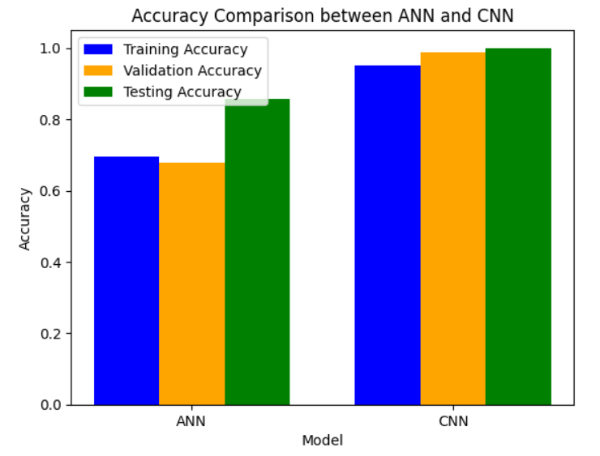

**Fig 5. Accuracy Comparison between ANN & CNN**

In scrutinizing the errors made by Artificial Neural Networks (ANNs) and Convolutional Neural Networks (CNNs) in counterfeit currency identification, a revealing comparison emerges. While both models strive for accuracy, CNNs exhibit a distinct advantage in minimizing errors. Despite ANNs' competence, CNNs consistently showcase fewer misclassifications, affirming their superior performance in distinguishing between genuine and counterfeit currency. This disparity underscores CNNs' adeptness in capturing intricate visual cues and patterns inherent in currency images, thereby mitigating erroneous predictions. Consequently, CNNs stand as the preferred choice for applications demanding precision and reliability, offering heightened assurance in currency authentication endeavors. Overall, the comparison highlights CNNs as the preferred choice for counterfeit currency identification tasks, thanks to their advanced feature extraction capabilities and robustness to image variations, leading to fewer errors and enhanced accuracy in authentication processes.

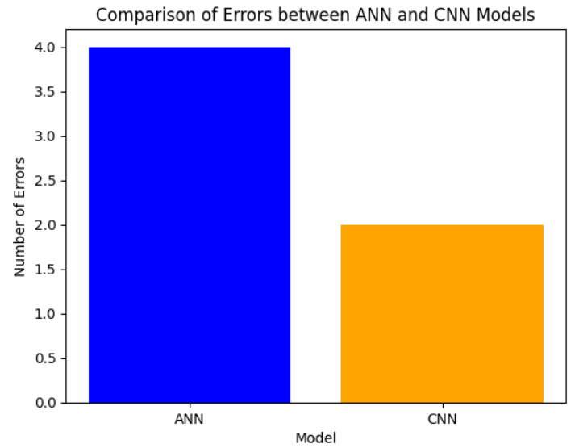

**Fig 6. Comparison of Errors between ANN & CNN**

In assessing the performance of Artificial Neural Networks (ANNs) and Convolutional Neural Networks (CNNs) in identifying counterfeit currency, the number of correct predictions serves as a pivotal metric. ANNs, with their simplified architectures, may struggle to discern intricate visual patterns inherent in currency images, resulting in fewer accurate classifications compared to CNNs. Conversely, CNNs, equipped with sophisticated convolutional layers designed for hierarchical feature extraction, excel in capturing nuanced visual cues. This enables them to make more accurate predictions, distinguishing between genuine and counterfeit currency with greater precision. Consequently, CNNs often yield a higher number of correct predictions, reflecting their superior ability to identify counterfeit currency reliably. The disparity in correct predictions underscores the efficacy of CNNs in currency authentication tasks, where precision and reliability are paramount. By leveraging advanced feature extraction techniques tailored for image data, CNNs offer heightened assurance in discerning counterfeit currency, thereby enhancing security and trust in financial transactions.

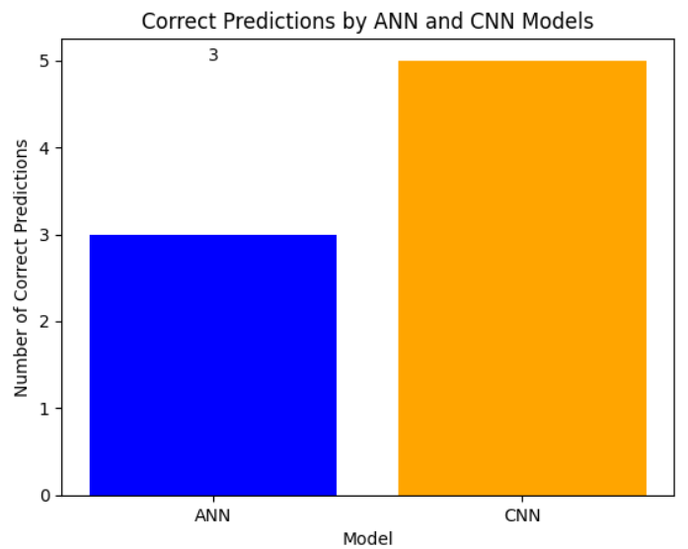

**Fig 7. Correct Predictions by ANN & CNN**

**For 2000 Rs Notes**

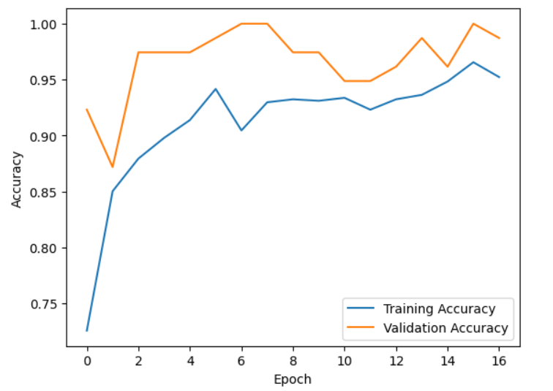

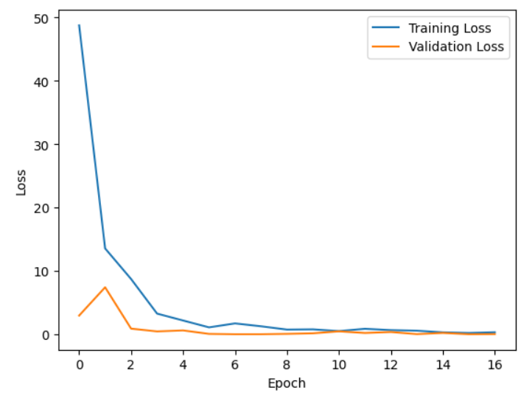

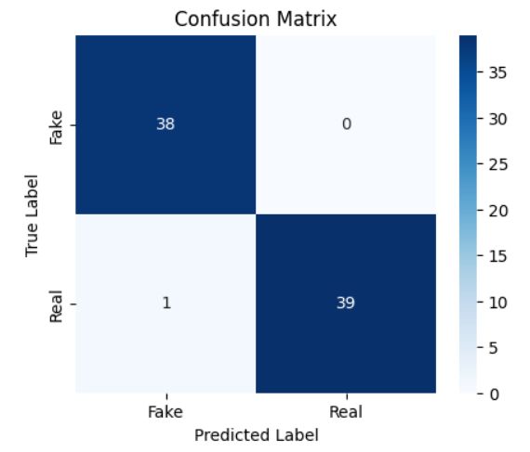

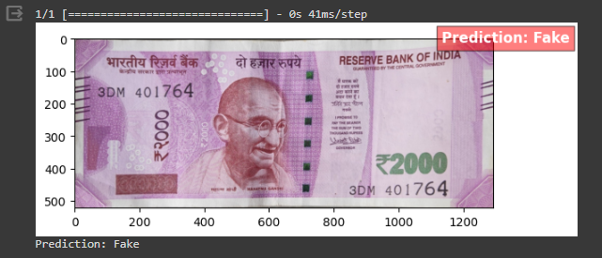

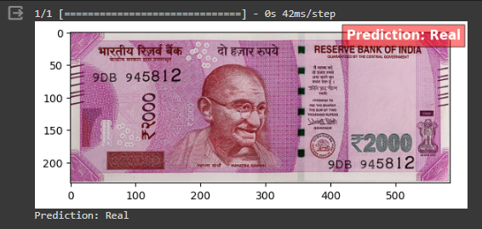

**For 500 Rs Notes** 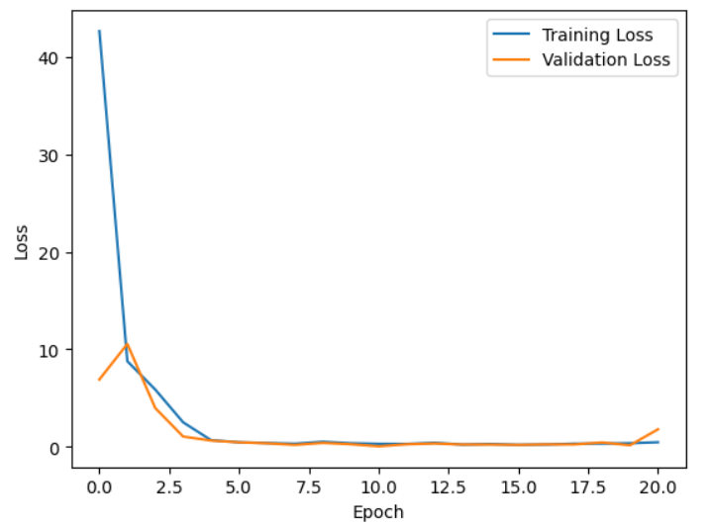

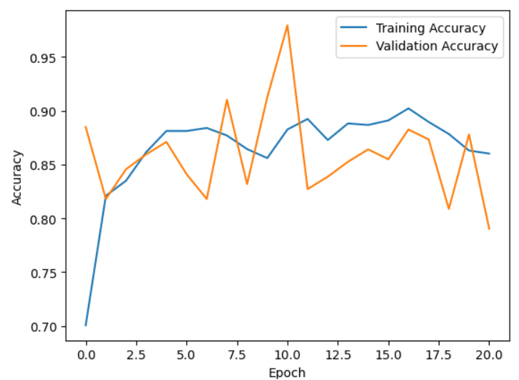

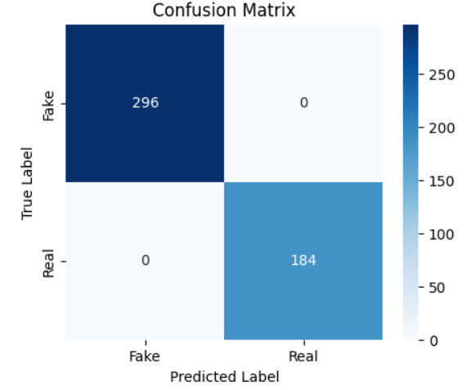

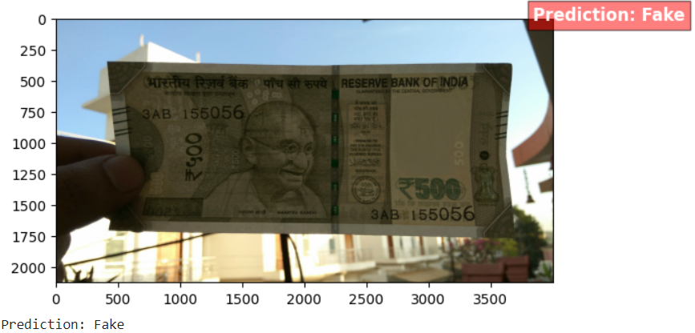

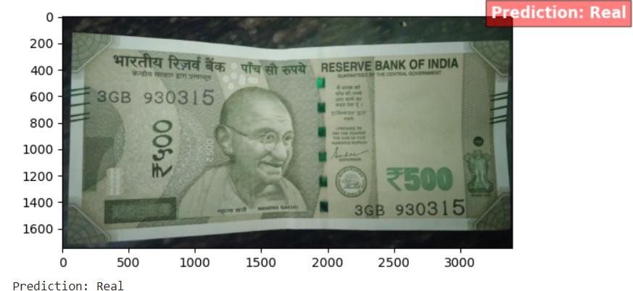

**For 100 Rs Notes**

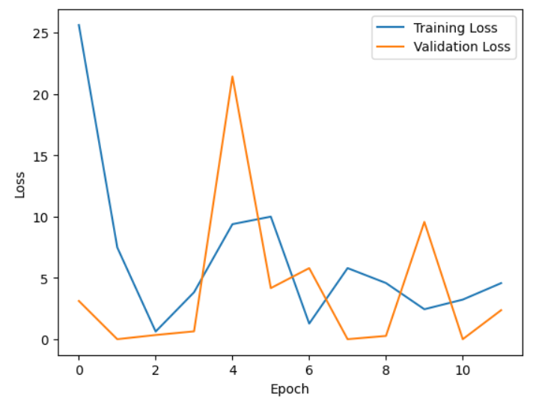

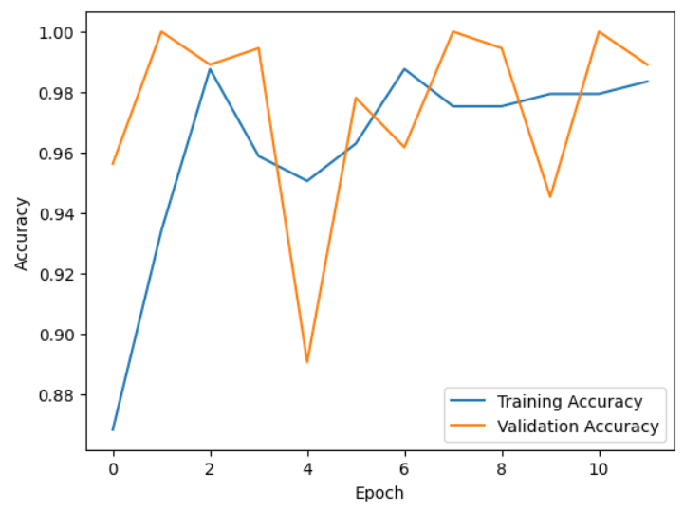

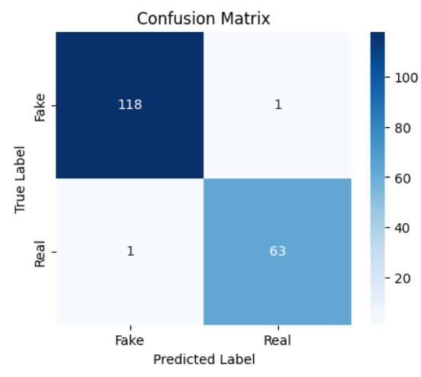

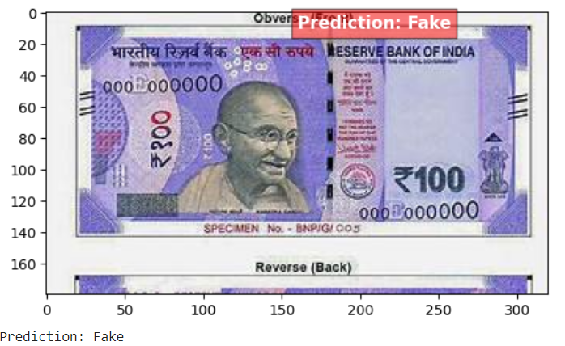

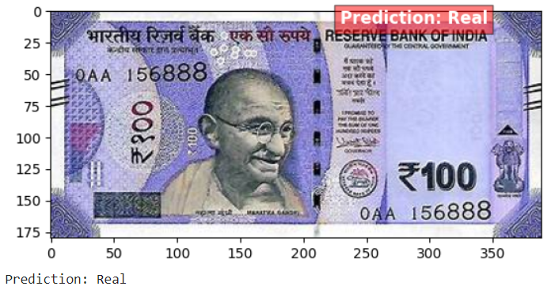

**For 50 Rs Notes**

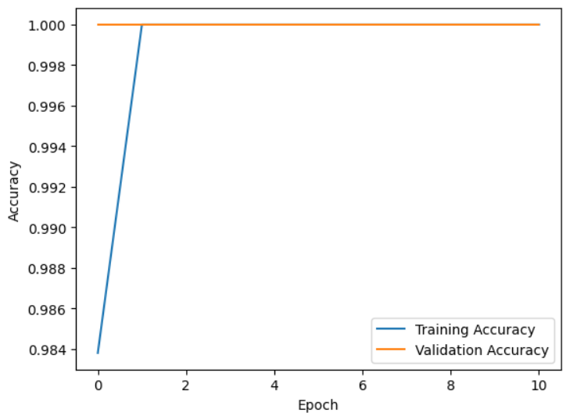

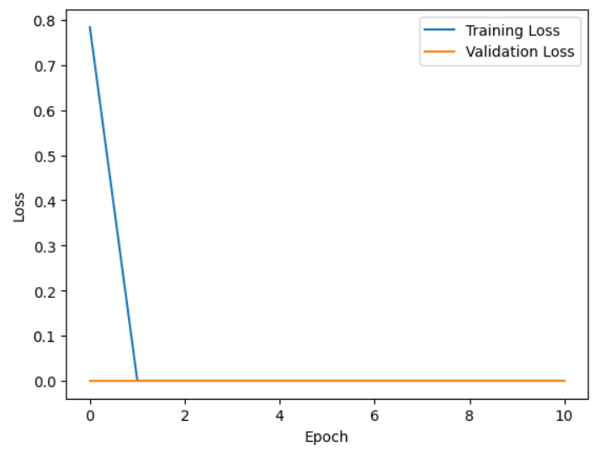

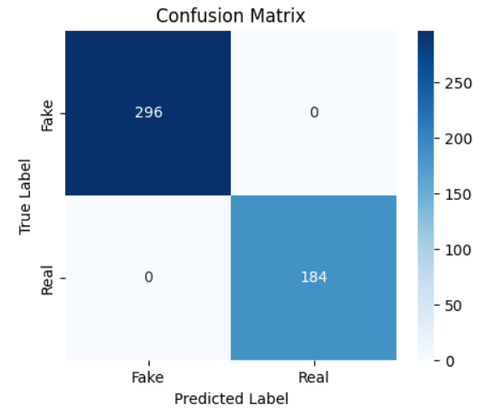

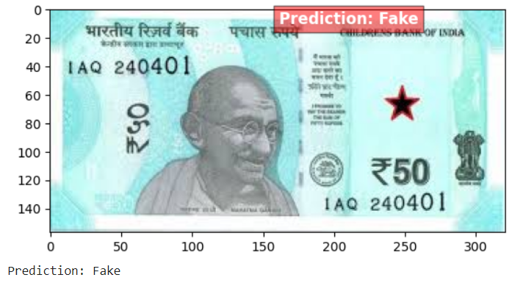

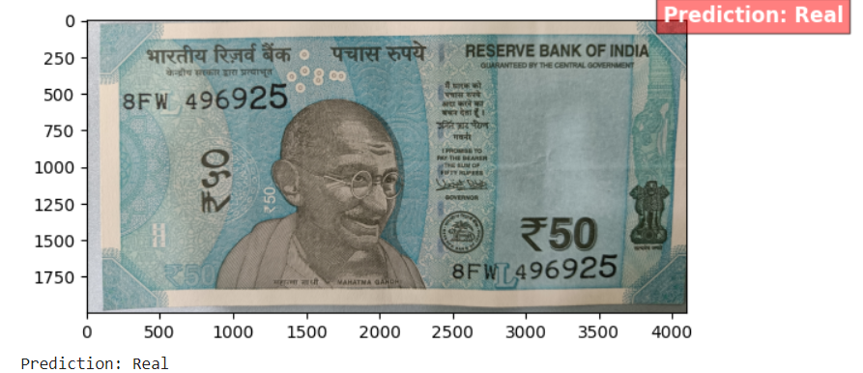

# **Advantages**

1. **Enhanced Security:** Reduces circulation of counterfeit currency, enhancing financial security.
2. **Time and Cost Savings:** Saves resources by automating currency authentication processes.
3. **Accuracy and Reliability:** Offers high accuracy in detecting counterfeit notes, minimizing errors.
4. **Scalability:** Can handle large volumes of currency notes efficiently.
5. **Adaptability:** Can be continuously updated to combat evolving counterfeit techniques.

# **Applications**

1. **Banking Sector:** ATMs, cash counters, and currency sorting machines.
2. **Retail Environments:** Cash payments verification in retail outlets.
3. **Government Agencies:** Law enforcement and regulatory bodies.
4. **Cash Processing Centers:** Bulk currency authentication facilities.
5. **International Trade:** Customs and border control authorities.
6. **Public Awareness:** Educating the public about counterfeit currency risks.

# **Conclusion**

The number of counterfeit notes on the market is rising quickly day by day. Different technologies are currently being utilised to assess whether a note is genuine or fraudulent money. The use of CNN in this study to identify counterfeit Indian cash has been suggested. We have chosen CNN as our paradigm for this proposed system's fake currency detecting process. Since the monetary distinctive attributes are gradually learned, the detection accuracy is at its highest. Here, the entire money picture has been taken into account, but in the future, we'll work to incorporate all of the security characteristics of cash by using appropriate structural design and training data. The acquired image may also contain noise, which must be taken into account as part of the pre-processing step in the currency detection process. By taking into account the surface patterns of the cash as characteristics, the recognition and fake currency detection can also be improved. The outcomes demonstrated the CNN's effectiveness, with Training Accuracy of 96.00% and Overall Accuracy of 97.00%.

# **References**

1. Rathee, Neeru, Arun Kadian, Rajat Sachdeva, Vijul Dalel, and Yatin Jaie. "Feature fusion for fake Indian currency detection." In *2016 3rd International Conference on Computing for Sustainable Global Development (INDIACom)*, pp. 1265-1270. IEEE, 2016.
2. Binod Prasad, C. S. Patil, R. R. Karhe, and P. H. Patil. "An automatic recognition of fake Indian paper currency note using MATLAB." *Int. J. Eng. Sci. Innov. Technol* 3 (2014): 560-566.
3. Laavanya, M., and V. Vijayaraghavan. "Real time fake currency note detection using deep learning." *Int. J. Eng. Adv. Technol.(IJEAT)* 9 (2019).
4. Agasti, Tushar, Gajanan Burand, Pratik Wade, and P. Chitra. "Fake currency detection using image processing." In *IOP Conference Series: Materials Science and Engineering*, vol. 263, no. 5, p. 052047. IOP Publishing, 2017.
5. Tele, Gouri Sanjay, Akshay Prakash Kathalkar, Sneha Mahakalkar, Bharat Sahoo, and Vaishnavi Dhamane. "Detection of fake Indian currency." *International Journal of Advance Research, Ideas and Innovations in Technology* 4, no. 2 (2018): 170-176.
6. Darade, Sonali R., and G. R. Gidveer. "Automatic recognition of fake Indian currency note." In *2016 international conference on Electrical Power and Energy Systems (ICEPES)*, pp. 290-294. IEEE, 2016.
7. Kumar, S. Naresh, Gaurav Singal, Shwetha Sirikonda, and R. Nethravathi. "A novel approach for detection of counterfeit Indian currency notes using deep convolutional neural network." In *IOP conference series: materials science and engineering*, vol. 981, no. 2, p. 022018. IOP Publishing, 2020.
8. Amirsab, Shaikh Ajij, Mohammad Mudassir, and Mohammad Ismail. "An automated recognition of fake or destroyed Indian currency notes." *International journal of advance scientific research and engineering trends volume* 2, no. 7 (2017).
9. Suresh, Ingulkar Ashwini, and P. P. Narwade. "Indian currency recognition and verification using image processing." *International Research Journal* *of Engineering and Technology (IRJET)* 3, no. 6 (2016): 87-91.
10. Kulkarni, Anushka, Prachi Kedar, Aishwarya Pupala, and Priyanka Shingane. "Original vs count counterfeit Indian currency detection." In *ITM Web of Conferences*, vol. 32, p. 03047. EDP Sciences, 2020.
11. Li Liu, Yue Lu “An Image-Based Approach to  Detection of Fake Coins” in IEEE  TRANSACTIONS ON INFORMATION  FORENSICS AND SECURITY June 2017.
12. [A Roy “Machine-assisted authentication of  paper currency: an experiment on Indian   
    bankknotes ”International Journal on Document  Analysis and Recognition, 18(3): 271-285, 2015. [3] Sun.Ke, “Detection of Counterfeit Coins and  Assessment of Coin Qualities” IEEE Conference  2015.
13. L. Liu “Variable-length signature for near duplicate image matching ” IEEE Conference  2015.
14. Jongpil Kim “Ancient Coin Recognition Based  on Spatial Coding” IEEE Conference 2015. [6] R. C. Gonzalez and R. E. Woods, Digital Image  Processing, 2nd ed., Prentice Hall India, ISBN 81-203-2758-6, 2006.M. Young, The Technical  Writer’s Handbook. Mill Valley, CA: University  Science, 198
15. Ms.Rumi Ghosh, Mr Rakesh Khare, “A Study on  Diverse Recognition Techniques for Indian  Currency Note” ,IJESRT, Vol.2, Issue 6, June  2013.R. Nicole, “Title of paper with only first  word capitalized,” J. Name Stand. Abbrev., in  press.
16. Amol A. Shirsath S. D. Bharkad, “Survey of  Currency Recognition System Using Image  Processing”, IJCER, Vol.3, Issue 7, pp 36-40, July  2013.
17. M.Deborah and Soniya Prathap “Detection of  Fake currency using Image Processing”. IJISET International Journal of Innovative Science,  Engineering & Technology, Vol. 1, Issue 10,  2014.
18. Faiz M. Hasanuzzaman, Xiaodong Yang, and  YingLi Tian, Senior Member, IEEE Robust and  Effective Component-based Banknote  Recognition for the Blind IEEE Trans Syst Man  Cybern C Appl Rev. 2012 Nov; 42(6): 1021– 1030.
19. Mohammad H Alshayeji, Mohammad Al Rousan and Dunya T. Hassoun, Detection  Method for Counterfeit Currency Based on Bit Plane Slicing Technique ,International Journal  of Multimedia and Ubiquitous Engineering  Vol.10, No.11 (2015).
20. Nayana Susan Jose, Shermin Siby, Juby  Mathew, Mrudula Das ,Android Based  Currency Recognition System for Blind,  International Journal of Engineering Research  in Computer Science and Engineering  (IJERCSE) Vol 2, Issue 4, April 2015
21. Rubeena Mirza, Vinti Nanda, Characteristic  Extraction Parameters for Genuine Paper  Currency Verification Based on Image  Processing, IFRSA International Journal of  Computing, Volume 2, Issue 2, April 2012.
22. Komal Vora, Ami Shah, Jay Mehta, A Review  Paper on Currency Recognition System,  InternationalJournal of Computer Applications  (0975 – 8887) Volume 115 – No. 20, April 2015.
23. G. Trupti Pathrabe, Mrs.Swapnili Karmore, A  Novel Approach of Embedded System for  Indian Paper Currency Recognition,  International Journal of Computer Trends and  Technology, May to June Issue 2011, ISSN:  2231-2803
24. Chanhum Park , Jiho Choi , and Kang Ryoung Park , ”Deep Feature- Based Three-Stage  Detection of Banknotes and Coins for Assisting Visually Impaired People,” October  21,2020.Digital Object Identifier 10.1109/ACCESSS.2020.3029
25. S. Mittal and S. Mittal, ”*Indian Banknote Recognition using Convolu- tional Neural  Network*,” 2018 3rd International Conference On Internet of Things: Smart Innovation  and Usages (IoT-SIU), Bhimtal, India, 2018, pp. 1-6, doi: 10.1109/IoT SIU.2018.8519888.
26. S.K. Katiyar and P.V. Arun “Comparative analysis of common edge detection techniques  in the context of object extraction.” India IEEE TGRS, 2017.
27. N.A. J. Sufri, N. A. Rahmad, N. F. Ghazali, N. Shahar “Vision Based System for  Banknote Recognition Using Different Machine Learning and Deep Learning  Approach” 2019 IEEE 2019
28. F. M. Hasanuzzaman, X. Yang and Y. Tian, ”Robust and effective component-based  banknote recognition for the blind”, IEEE Transac- tions , 2018.
29. V. Abburu, S. Gupta, S. Rimitha, M. Mulimani, and S. Koolagudi. “Currency recognition  system using image processing” IEEE Computer Society, (2017).